K213881

Applied Devops

Quiz

Problem 1

Test (QA folder only)

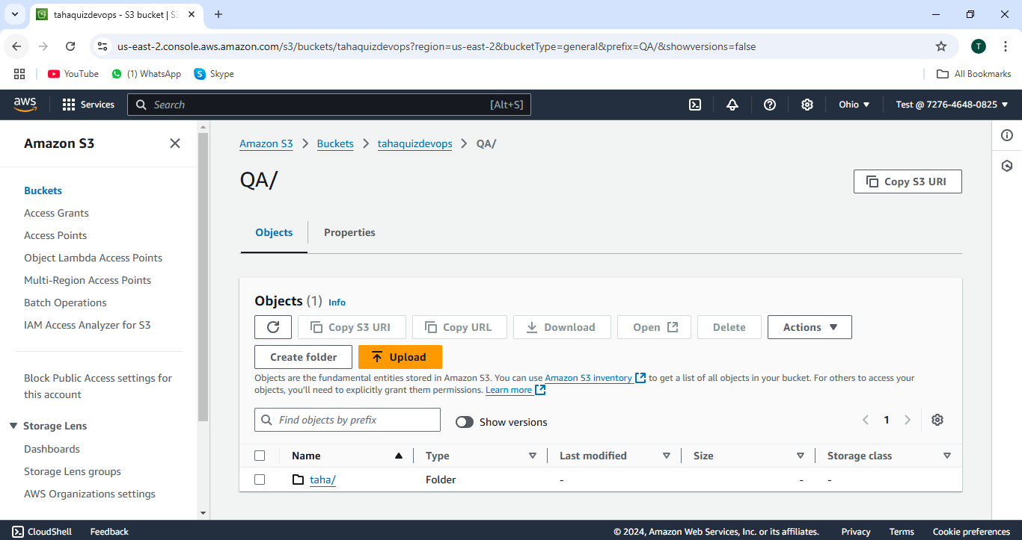

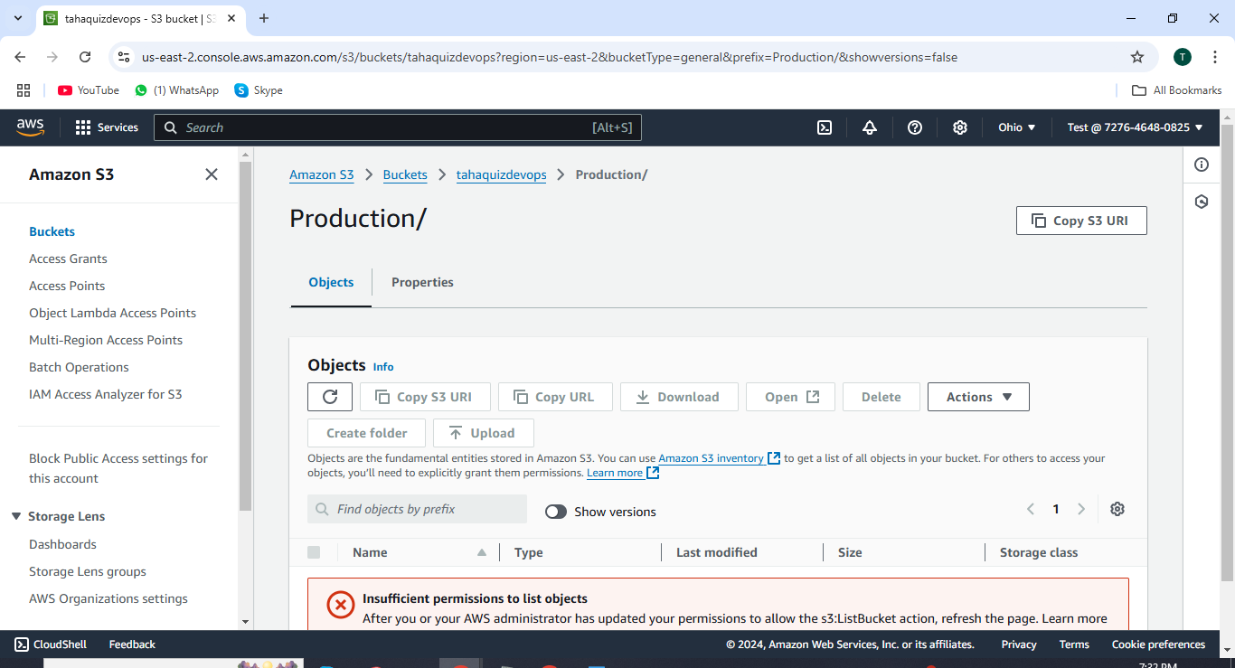

Stage (Staging folder only)

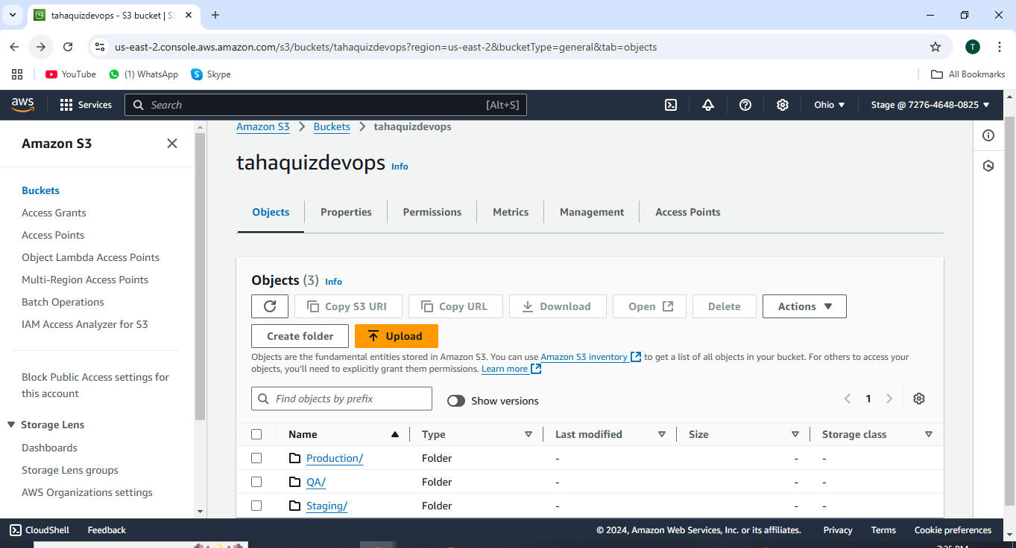

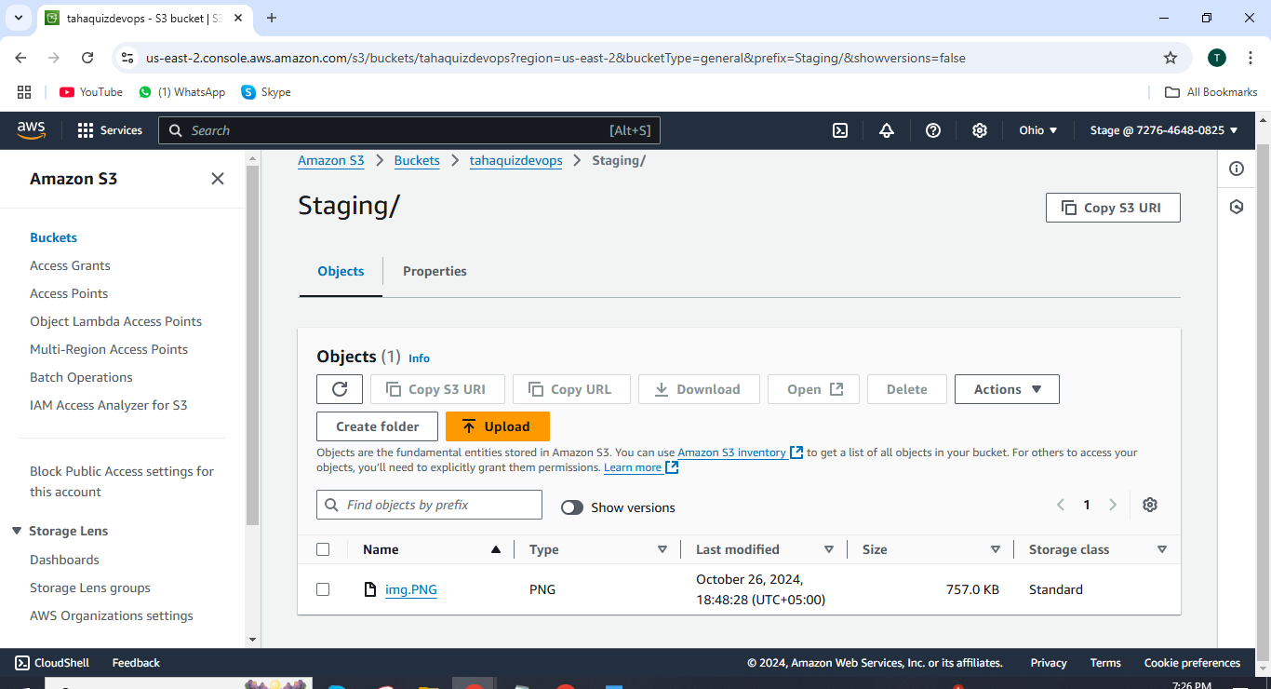

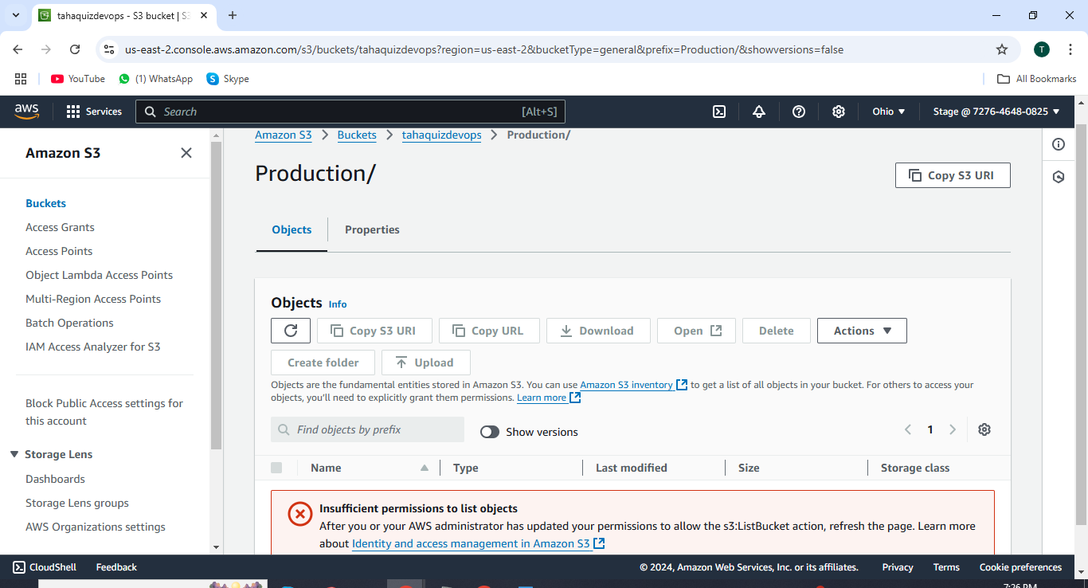

Root user production access:

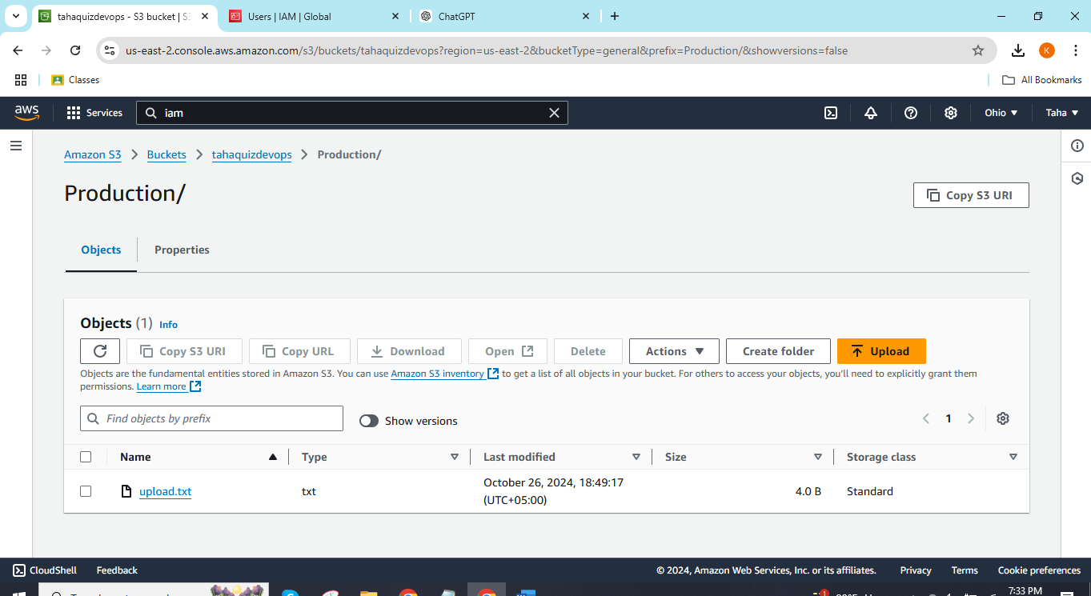

IAM USERS:

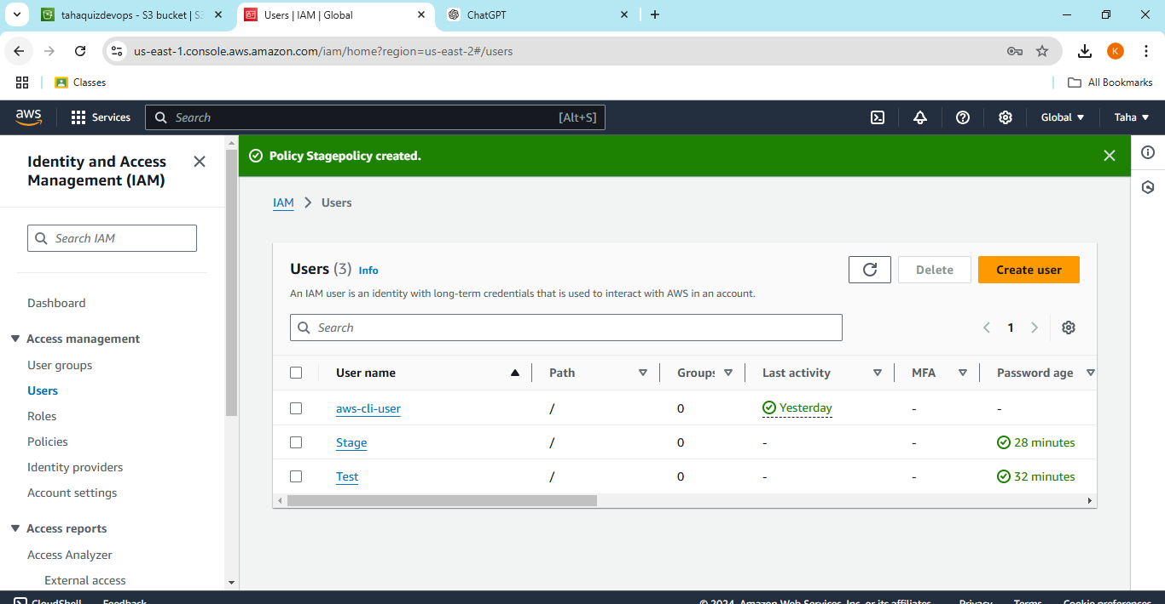

Problem 2:

First vpc :

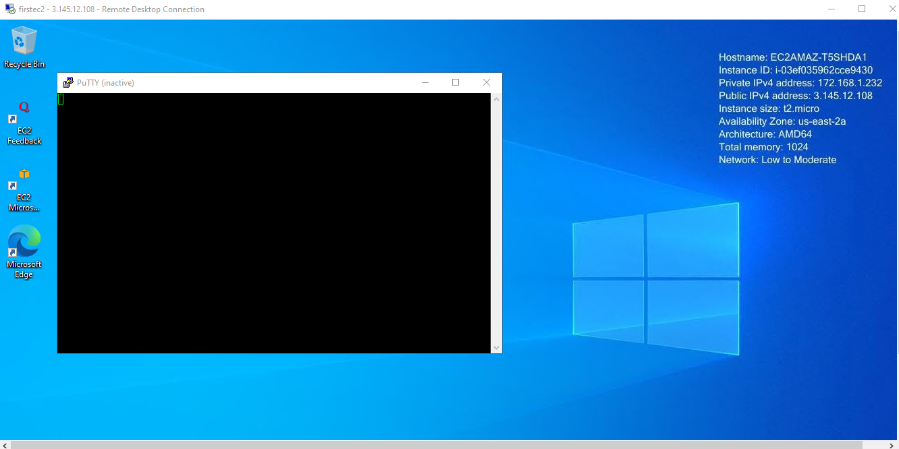

2nd vpc :

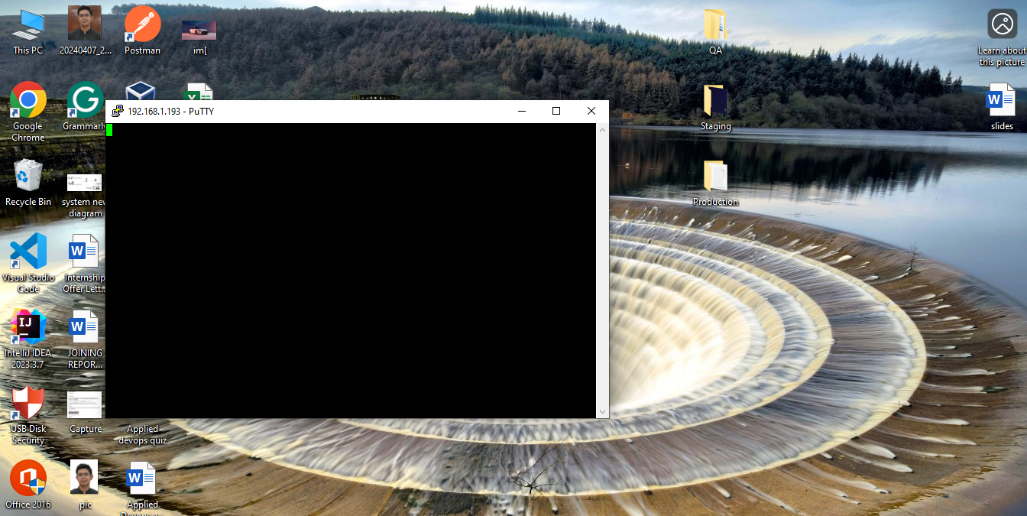

Perring two vpcs in different regions:

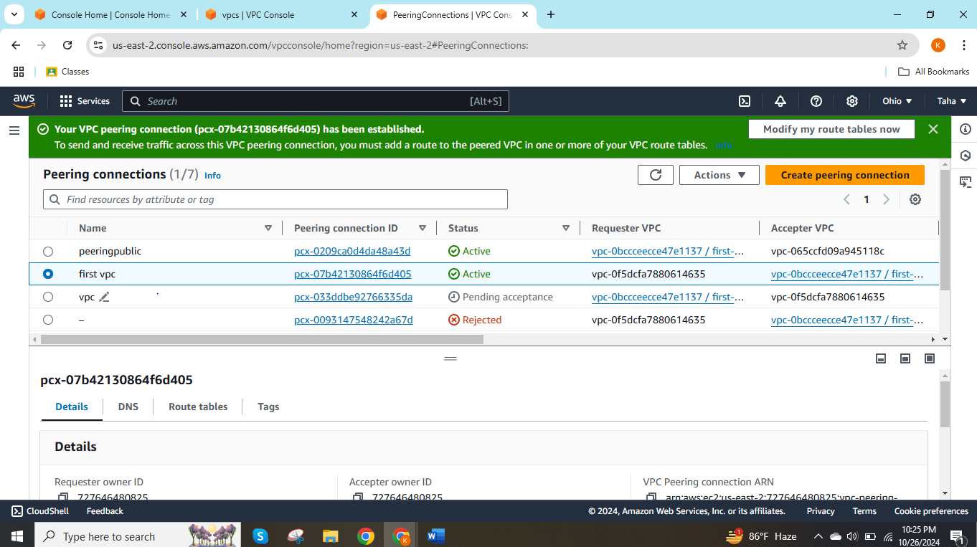

Peerring b/w two d/f accounts:

Naresh kumar

K213881

Account id: 539247472442

